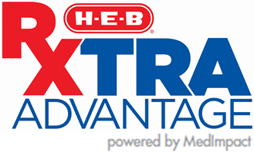
FAQ
KATY ISD
Effective January 1, 2026

Who do I contact if I have questions about the pharmacy benefit program?
For questions about the pharmacy benefit program, please contact H-E-B RxTRA Advantage Member Services at 1-877-432-6315. Representatives are available 24 hours a day, 7 days a week to assist with pharmacy-related questions.
If you need additional assistance, please contact Katy ISD Benefits Helpline: 1-866-222-KISD (5473) (Monday–Friday, 8 a.m.–5 p.m. CT).

Where can I fill my prescriptions?
You are required to use an H-E-B Pharmacy to fill your prescriptions. Non-H-E-B pharmacies within a 10-mile area of an H-E-B Pharmacy are considered Out-of-Network. If there is not an HE-B Pharmacy in your area, a select Network of pharmacies has been set up around the country and in Texas for your convenience. Employees can locate an H-E-B or participating network pharmacy by visiting the H-E-B RxTRA Advantage/MedImpact Pharmacy Portal (www.rxtraadvantage.com) and creating an account using your Aetna ID number.
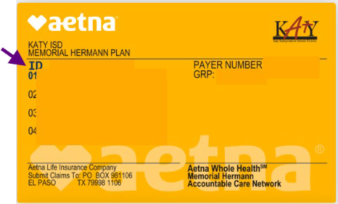

What if I do not live near an H-E-B pharmacy?
If there is not an HE-B Pharmacy in your area, a select Network of pharmacies has been set up around the country and in Texas for your convenience. Visit the H-E-B RxTRA Advantage/MedImpact Pharmacy Portal (www.rxtraadvantage.com) to find eligible network pharmacies by zip code and driving directions.

When will I receive my prescription ID card?
Prescription ID cards, issued by Aetna, were mailed to employees’ home addresses in December 2025 and include both medical and prescription coverage.

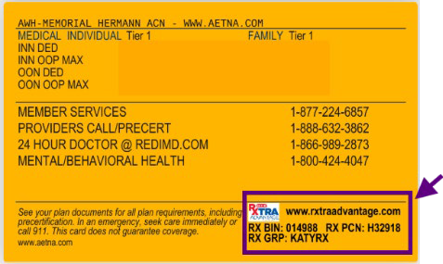
If you have not yet received your ID card, you can still access your benefits. Simply visit any H-E-B pharmacy and inform them that you are a Katy ISD employee. The pharmacy can retrieve your insurance information and process your prescription. You may also log in to aetna.com to view or print a copy of your ID card.

How can I move my prescriptions to an H-E-B pharmacy?
You have three simple options:
- Call your local H-E-B pharmacy and ask them to transfer your prescription. You may need details from your current prescription bottle.
- Visit an H-E-B pharmacy in person and bring your prescription bottles. Staff will help handle the transfer for you.
- Use the H-E-B mobile app to request a prescription transfer directly from your phone.
For questions, contact H-E-B RxTRA Advantage Member Services at 1-877-432-6315 or visit the H-E-B RxTRA Advantage/MedImpact Pharmacy Portal (www.rxtraadvantage.com).

Where can I find my prescription drug copay?
You can view prescription drug copays and pricing information by creating an account on the H-E-B RxTRA Advantage/MedImpact Pharmacy Portal (www.rxtraadvantage.com)
To register, you will need your Aetna ID.
Once your account is created and your email is confirmed, you can log in to:
- Check drug prices and copays
- View benefit highlights
- Access your prescription history

I currently use mail order for 90-day prescriptions. How will I fill a 3-month supply with H-E-B?
H-E-B does not offer traditional mail-order pharmacy services. As of January 1, 2026, all 90-day (3-month)

prescriptions must be filled at an H-E-B retail pharmacy or participating in network pharmacies. To avoid delays, you are encouraged to transfer your prescriptions to H-E-B in advance. You can:
- Contact your local H-E-B pharmacy to request a transfer, or
- Bring your prescription bottles to an H-E-B pharmacy for assistance
- Use the H-E-B mobile app to request a prescription transfer directly from your phone.
H-E-B pharmacies can fill up to a 90-day supply of maintenance medications at retail locations. If there is not an HE-B Pharmacy in your area, you may use an approved RxTRA Advantage network pharmacy.

For questions or assistance, contact H-E-B RxTRA Advantage Member Services at 1-877-432-6315 or visit the H-E-B RxTRA Advantage/MedImpact pharmacy portal (www.rxtraadvantage.com).

Do I need a new Prior Authorization (PA) After January 1, 2026?
If you had a prior authorization (PA) in place before January 1, 2026, it would transfer to the new system and should continue without interruption.

You will need a new PA if:
- Your current authorization has expired and requires a PA renewal, or
- Your medication is not covered on the new formulary (a one-time courtesy fill will be allowed, and you will receive a notification letter that your medication is not covered under the new formulary) or
- You are starting a new medication that requires a PA (your provider must submit a request for approval)
If your medication is a specialty drug, the authorization process may involve MedImpact Direct Specialty Pharmacy (Please refer to MedImpact Direct Specialty Pharmacy FAQ section below).

For assistance, contact:
- H-E-B RxTRA Advantage Member Services: 1-877-432-6315 (Available 24/7)
- MedImpact Direct Specialty Pharmacy: 1-877-391-1103 (Monday–Friday, 8 a.m.–4 p.m. CT)
- Katy ISD Benefits Helpline: 1-866-222-KISD (5473) (Monday–Friday, 8 a.m.–5 p.m. CT)

How are prescriptions filled for members who live out of state or are traveling?
If you or a covered dependent lives outside of Texas and is attending school out of state, traveling, or there’s not an H-E-B Pharmacy in your area, you may use a participating RxTRA Advantage network pharmacy. The network includes nearly 60,000 pharmacies nationwide, providing convenient access when H-E-B is not available.

You may use a network pharmacy if:
- You or your dependent lives outside of Texas
- You are traveling or on vacation
- If there is not an H-E-B Pharmacy in your area

I just left the emergency room and have to fill a prescription but H-E-B Pharmacy is closed. What can I do?
If you had an emergency and need to fill a prescription outside of the H-E-B Pharmacy operating hours, you may use a 24-hour pharmacy, such as Walgreens or CVS, one time to fill your medication. Once your immediate need is met, any refills must be transferred to an H-E-B Pharmacy or

an approved network pharmacy.
To find a participating pharmacy:
- Visit www.rxtraadvantage.com and create an account using your Aetna ID number
- Use the pharmacy search tool to locate nearby network pharmacies
- Call H-E-B RxTRA Advantage Member Services at 1-877-432-6315 for assistance

My medication is experiencing a shortage at H-E-B. What can I do?
H-E-B actively monitors medication availability, including national shortages. If your medication is unavailable or in short supply, you may request assistance through H-E-B RxTRA Advantage.
Please contact H-E-B RxTRA Advantage Member Services at 1-877-432-6315. If a shortage is confirmed, a
one-time override may be approved to allow you to fill a prescription at a participating network pharmacy. If the shortage continues, additional overrides may be required for future refills.
To find a nearby participating pharmacy:
- Visit the H-E-B RxTRA Advantage/MedImpact Pharmacy Portal (www.rxtraadvantage.com) and “Create an Account” using your Aetna ID number.
- Use the pharmacy search tool to locate nearby participating pharmacies.
- Call H-E-B RxTRA Advantage Member Services at 1-877-432-6315 for assistance.

WELCOME TO MEDIMPACT SPECIALTY PHARMACY CARE

What is MedImpact Direct Specialty®?
  - This is Katy ISD’s specialty pharmacy program.
  - It provides medications and support for chronic or complex conditions, along with personalized care.

What if my prescription requires specialty pharmacy services?
If you take specialty medications for chronic or complex conditions (such as rheumatoid arthritis or hepatitis C), support is available through the MedImpact Direct Specialty Pharmacy at 1-877-391-1103 (TTY: 711) or visit www.medimpact.com for details about your prescription benefits.
Your medication can be delivered to your home, your doctor’s office, or another location of your choice. Standard delivery is provided at no cost, and packaging is designed to protect your privacy.

What services are provided by the specialty pharmacy program?
The specialty pharmacy program offers added support to help you manage your medications and achieve the best possible outcomes. Services include:
- Assistance with your treatment plan
- Help with copay assistance programs
- Access to a nurse and pharmacist helpline (Monday–Friday, 8 a.m.–8 p.m. ET)
- 24-hour emergency support
- Educational resources
- Translation services
- Personalized refill reminders and coordination
- Free standard shipping

